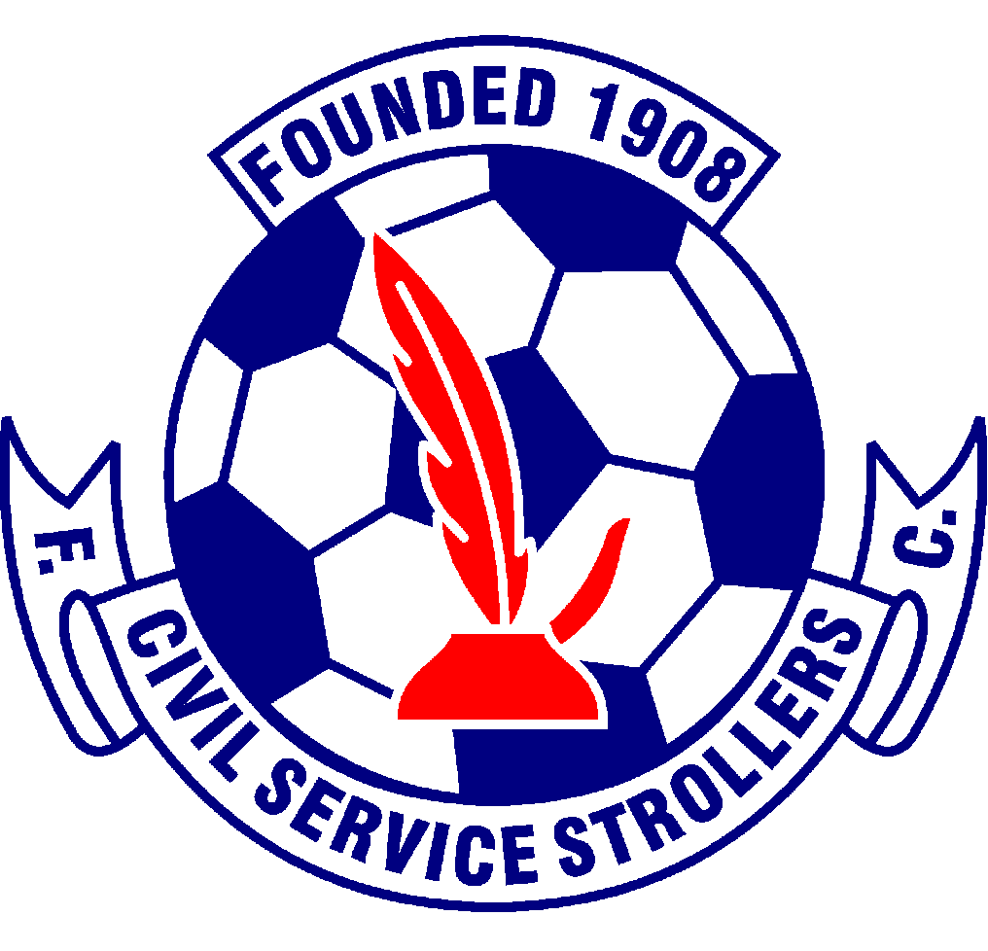

Civil Service Strollers Amateur Football Club

Customer Charter

The Customer /Supporter Charter sets out the commitment of a football club to give its supporters a safe and enjoyable experience of football.

The club undertakes to keep its supporters informed as to changes at the club by whichever means it decides is the most cost effective.

The club undertakes to keep its supporters informed on a regular basis by whatever means it decides are appropriate and cost effective.

The club undertakes to keep the supporters informed as to fixture changes by whatever means it decides is most appropriate.

The club undertakes to provide a clean and safe ground with appropriate facilities.

The club undertakes to provide access for those with special needs, refer to the club’s disability policy.

The club undertakes to encourage an environment free of sectarian and racial abuse.

Issue 1 – July 2014
Issue 2 – 07.06.2016
Issue 3 – 12.05.2017
Issue 4 – 21.02.2018
Issue 5 – 19.05.2021
Issue 6 – 06/06/2022
Issue 7 – 25/06/2023

