Club Name: | CIVIL SERVICE STROLLERS

Option A
To be completed by all member clubs who are adopting the Scottish Football Child Wellbeing and Protection Policy directly.
The club has adopted Scottish football’s Child Wellbeing and Protection Policy without amendment:  - Part 1 – Introduction  - Part 2 – Policy Statement  - Part 3 – Set the Standards  - Part 4 – Procedures  - Appointment and Selection  - Responding to Concerns  - Case Review  - Part 5 – Practice Notes  - Anti-Bullying  - Behaviours  - Celebration  - Communication and Social Media  - Health  - Planning and Organisation  - Prevention Planning  - Relationships  - Travel and Trips Away | ☐
The policy includes an Introduction from the club’s Chief Executive or Chairperson | ☒
The policy is available on the club’s website | ☒
Please insert link to website page here:
https://www.csstrollers.com/wp-content/uploads/2019/09/New-Strollers-Child-Wellbeing-and-Protection-Policy-Sept-2019.pdf

The information contained on the checklist on page 1 will be used for Club Licensing purposes and all information included should be true and accurate.

We the undersigned confirm that:
- The information contained on the above checklist is true and accurate.
Name and position of authorised club signatory: | Keith Stewart
Signed: | 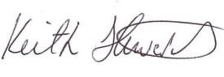
Name of Child Wellbeing and Protection Officer: | Russell Pryde
Signed: | 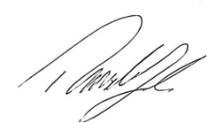
For and behalf of Civil Service Strollers Football Club
Date: 20/1/2021

Issue 2 – 06/06/2022 – KS
Issue 3 – 25/06/2023 - KS

