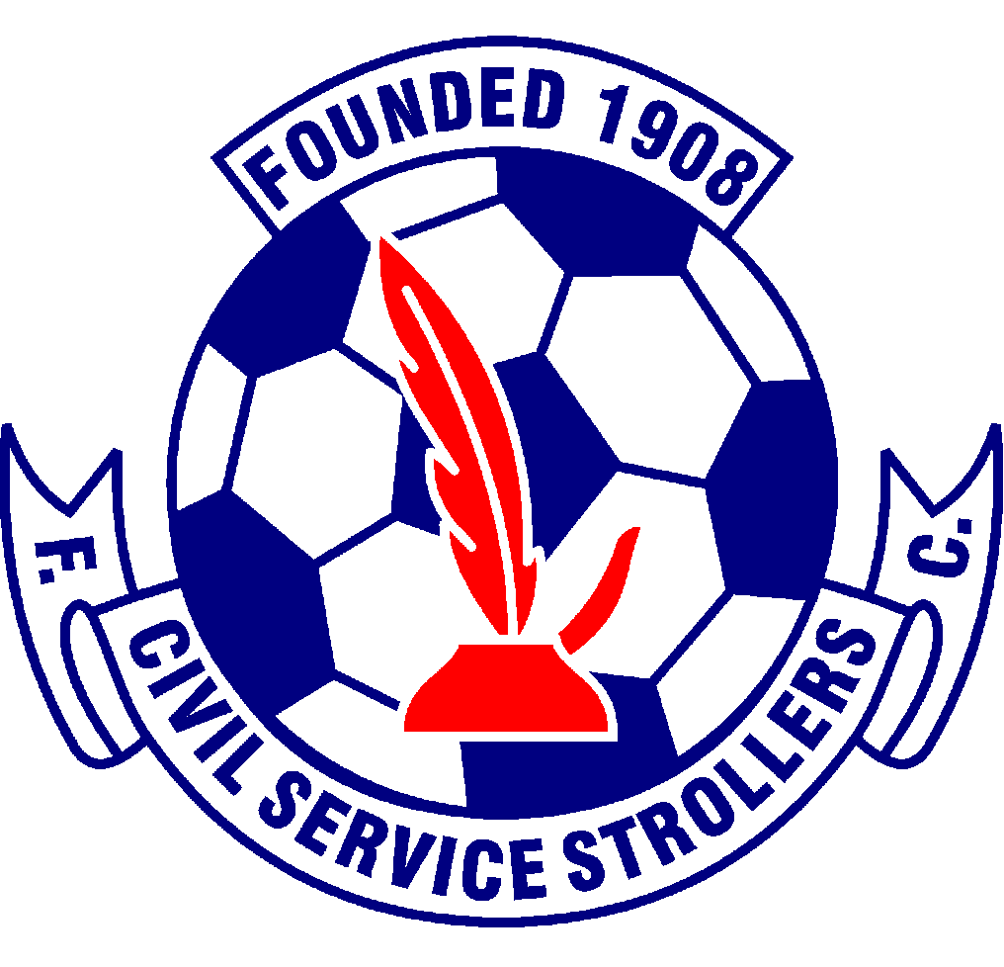
Civil Service Strollers Amateur Football Club

SPECTATORS CODE OF CONDUCT and GROUND RULES.

Civil Service Strollers AFC
Promotes the conduct to the spirit of Fair Play which is essential for the successful promotion and development of and involvement in sport. The objective of Fair Play is to foster a sporting spirit, as well as the sporting behaviour of those involved in sport including spectators, thereby increasing the enjoyment of all those involved in the game.

The crowd is considered to be an organic component of a football match. The support of fans may contribute to the success of the team. The crowd is not expected to watch the game in silence. Encouragement of the teams by shouting, non abusive singing, etc may have a positive influence on the atmosphere in accordance with the spirit of Fair Play.

Civil Service Strollers AFC expects their supporters to respect their opponents and match officials. They should appreciate the performance of the opposition even if they emerge as winners. They should in no way attempt to intimidate opponents, the match officials, or opposing spectators. At all times the supporters are encouraged and expected to comply with the club’s position on Discrimination and Unacceptable Conduct.

Ground Rules:
- No Smoking in any area of the ground.
- No alcohol to be consumed in any area of the ground.
- Sectarian chants will not be tolerated in or around the ground.
- No projectiles or Pyrotechnics will be allowed in the ground.
- Emergency procedures will be announced prior to the game and repeated at half time, please make sure you are familiar with escape routes.
- Spectators should respect areas marked No Spectator access, these areas are designated for protection of players and officials.

Failure to comply with any of the above may result in expulsion from the ground and may result in criminal charges being brought against any guilty party.

For General information
Issue 2 – 21.07.2016 Issue 3 – 12.05.2017 Issue 4 – 21.02.2018
Issue 5 – 24/06/2021
Issue 6 – 06/06/2022 – KS
Issue 7 – 25/06/2023 - KS

