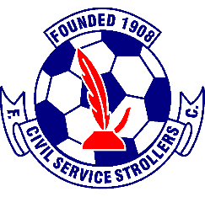

Civil Service Strollers Amateur Football Club
Disability Policy

The club are committed to the provisions set out in The Equality Act 2010 and will strive to excel in their commitment. The club is committed to supporting the principle of equal opportunities in employment and opposes all forms of unlawful and unfair discrimination on the grounds of disability.
The Club is committed to ensuring that its disabled supporters and customers have as full access as is reasonably possible to make to all goods, services and facilities provided to the public by the club.
The club recognises that not all its facilities are fully accessible to customers who are disabled and confirms that it is committed to making the necessary reasonable adjustments required by the Equality Act 2010 and its relevant Codes of Practice to ensure full compliance with the legislation.
Pricing Policy for Civil Service Strollers F.C. controlled events, is that spectators who are disabled pay a concession price with one personal assistant (if required) admitted on a complimentary basis.
The club policy for supporters who are disabled is that we do not discriminate between people who are disabled with different medical conditions.
The club guarantees to its supporters and customers who are disabled that any complaints of discrimination will be dealt with.
The club will deal with any incident of discrimination under the provisions of the Equality Act 2010 as a serious matter and will be dealt with under the club disciplinary procedures.
Issue 2 – 06/06/2022- KS
Issue 3 – 25/06/2023 - KS

