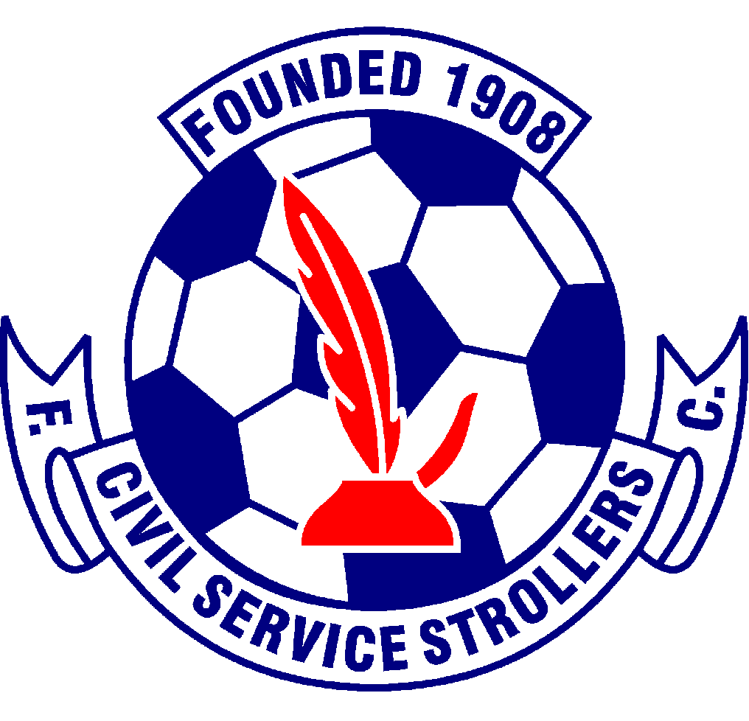

ANTI DISCRIMINATION POLICY for
Civil Service Strollers Amateur Football Club

Civil Service Strollers AFC is responsible for setting standards and values to apply throughout the club at every level. Football belongs to and should be enjoyed by everyone, equally. Our commitment is to confront and eliminate discrimination or any other conduct that could be deemed as unacceptable whether by reason of sex, sexual orientation, race, nationality, ethnic origin, colour, religion or disability.

Equality of opportunity at Civil Service Strollers AFC means that in all our activities we will not discriminate or in any way treat anyone less favourably, on grounds of sex, sexual orientation, race, nationality, ethnic origin, colour, religion or disability.

This includes :

- The advertisement for volunteers.
- The selection of candidates for volunteers
- Courses
- External coaching and education activities
- Football development activities
- Selection for teams
- Appointment to honary positions
- Civil Service Strollers AFC will not tolerate racist, sectarian or bigoted harassment or other discriminatory behaviour, whether physical or verbal, and will work to ensure that such behaviour is met with appropriate action in whatever context it occurs.
- Civil Service Strollers AFC is committed to the development of the programme of ongoing training and awareness raising events and activities, in order to promote the eradication of discrimination within its own organisation, and within football as a whole.
- Civil Service Strollers AFC gives a commitment to ensure that the club is open to all and the team selection policy will be the footballing ability and character of the individual and the collective balance of the team.
- Issue 1 – July 2014
- Issue 2 – 07.06.2016
- Issue 3 – 12.05.2017
- Issue 4 – 21.02.2018
- Issue 5 – 24/06/2021
- Issue 6 – 06/06/2022 - KS
- Issue 7 – 25/06/2023 - KS

